I started with going over sketches I did for the chess model.

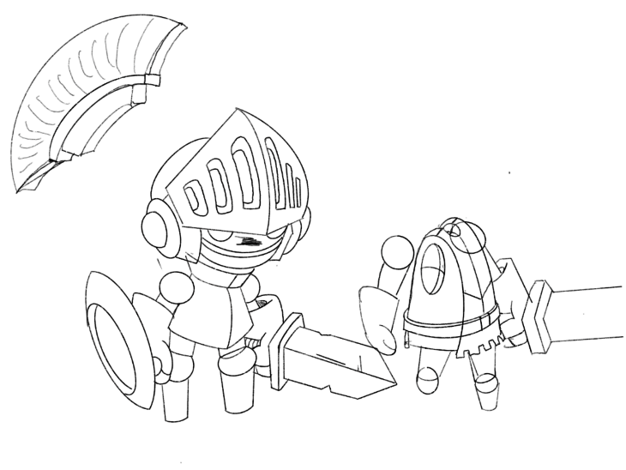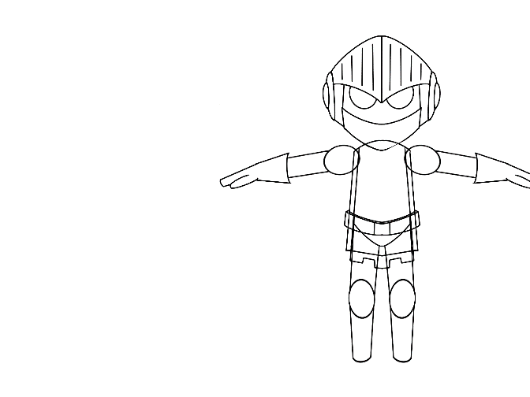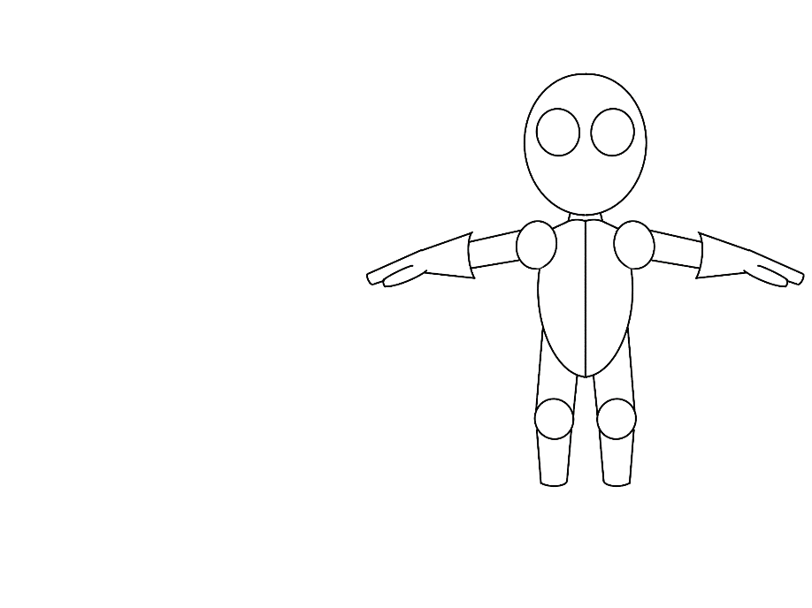

Eairliest maya file before I stage saved I forgot to take picture from the beging this is about one third into the work process. I modeled my model from cubes using cuts, subdivisions and bevels I was able to mold my model into the desired shape of the knight.

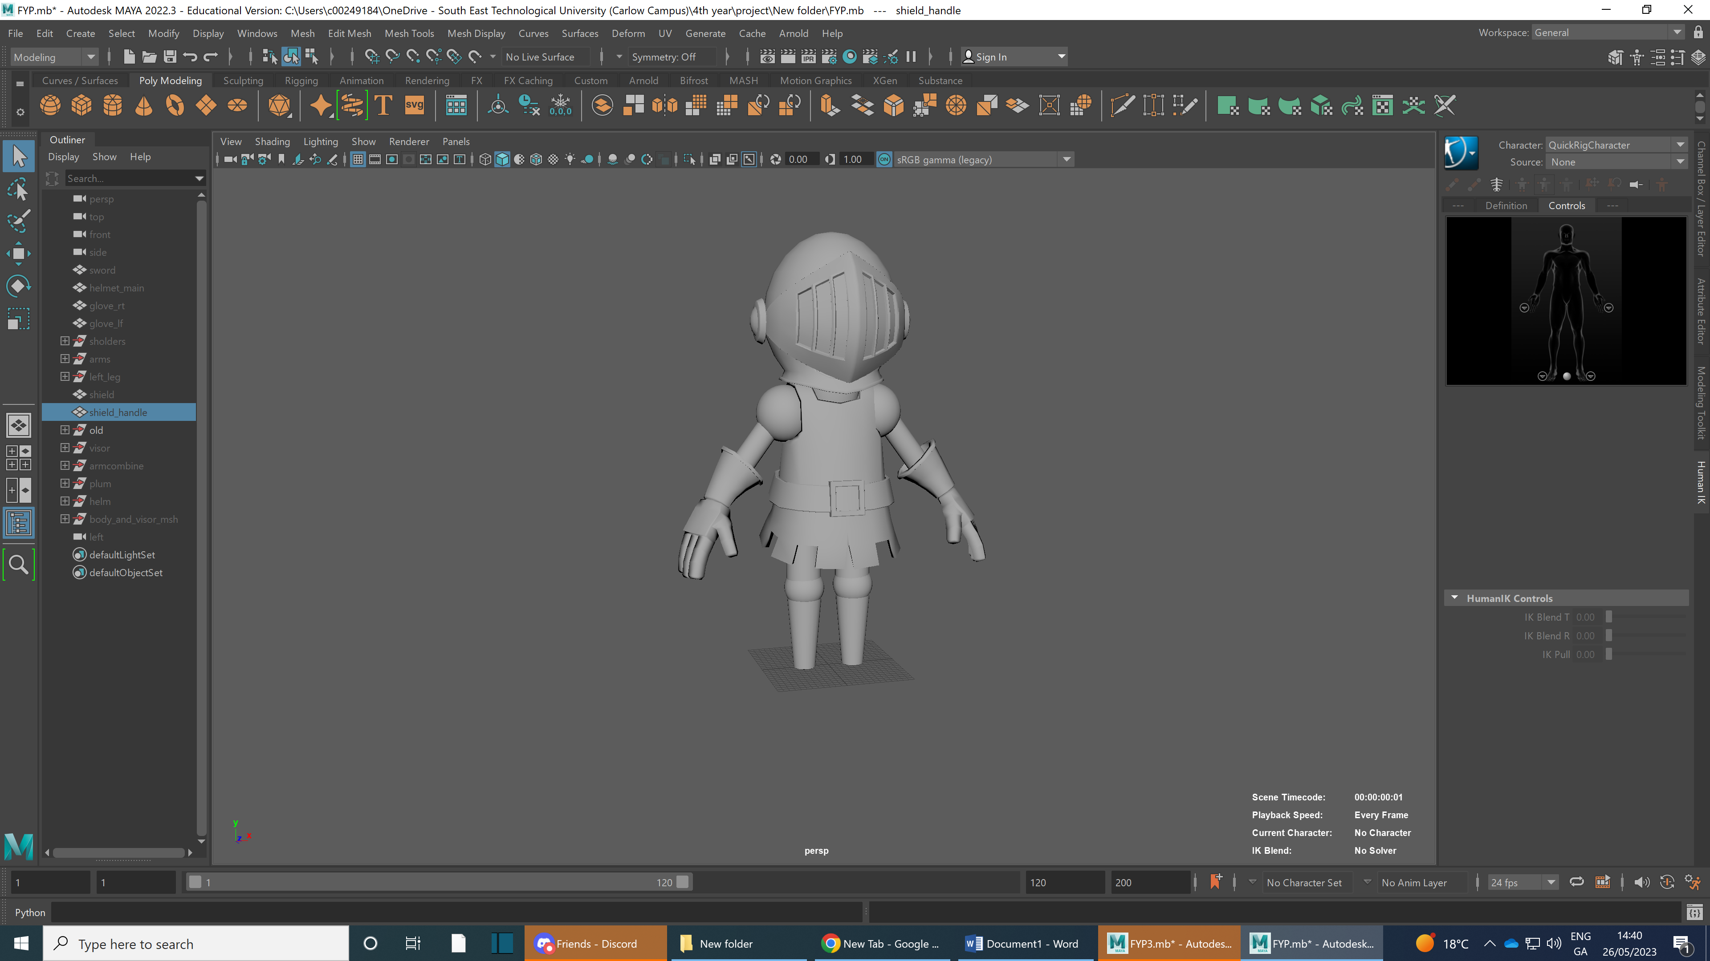

This next stage is when I stitched all edges and vertices togeter and then afterwards thought adding shoes was good idea as it made the model looks better.

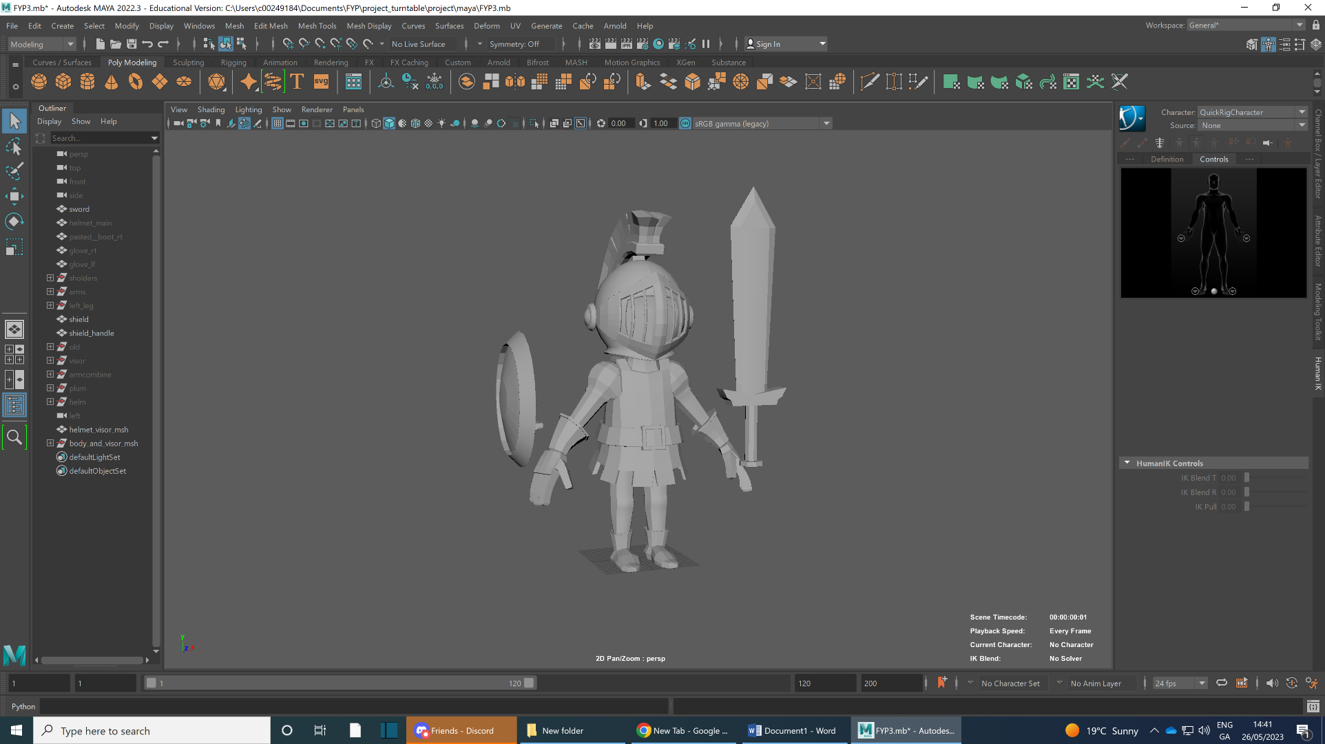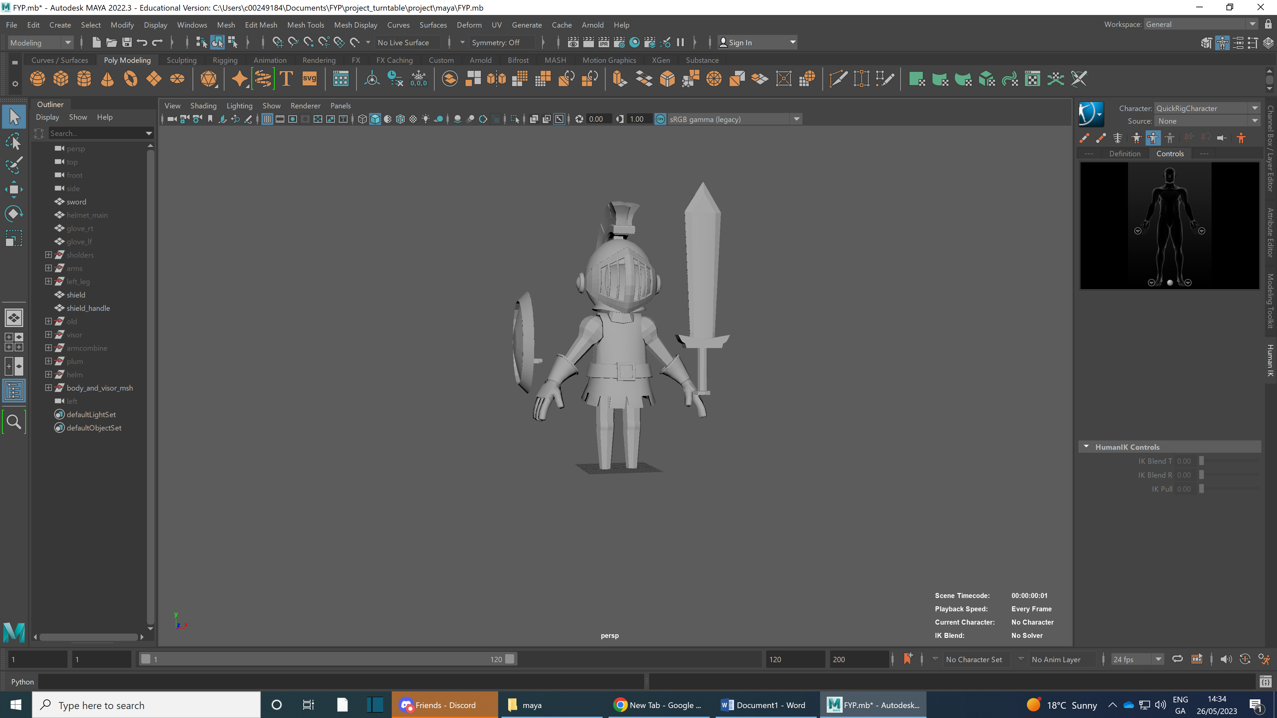

When I got to the end of using aya I did riging to see if it transfers well to blender. Sadely it did not so I will need to rig the model in blender. I also check the smoothed version.

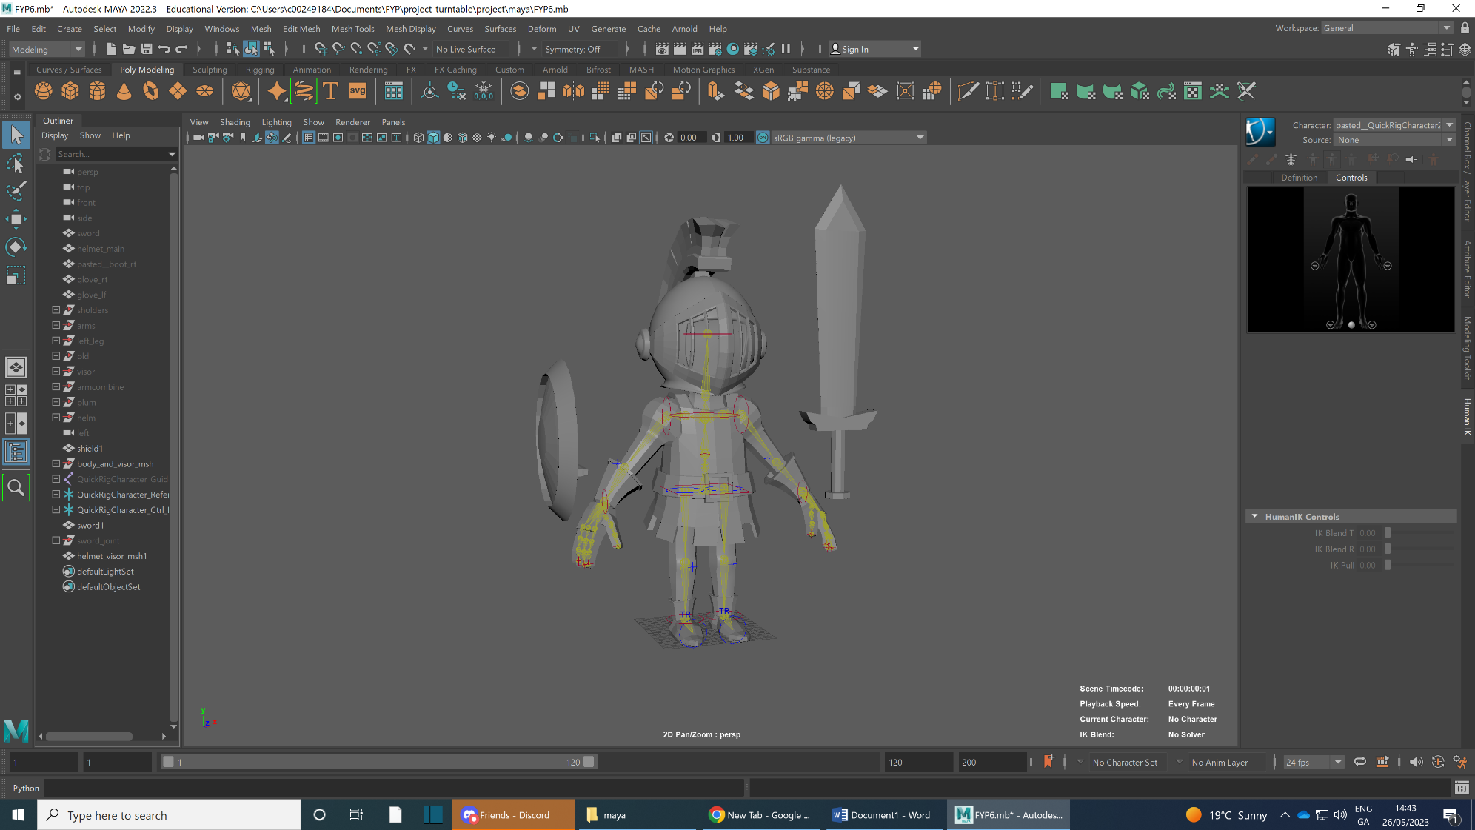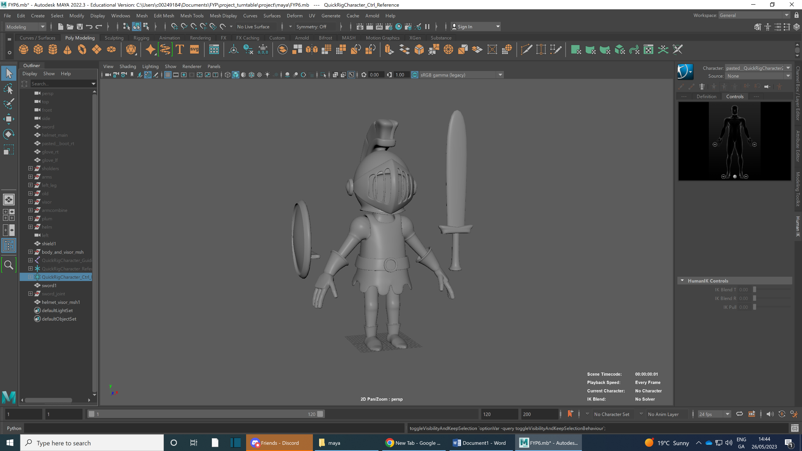

This was when I was working substance as soon as I finished modelling in Maya I exported and FBX of model assets and imported it into Substance to texture it

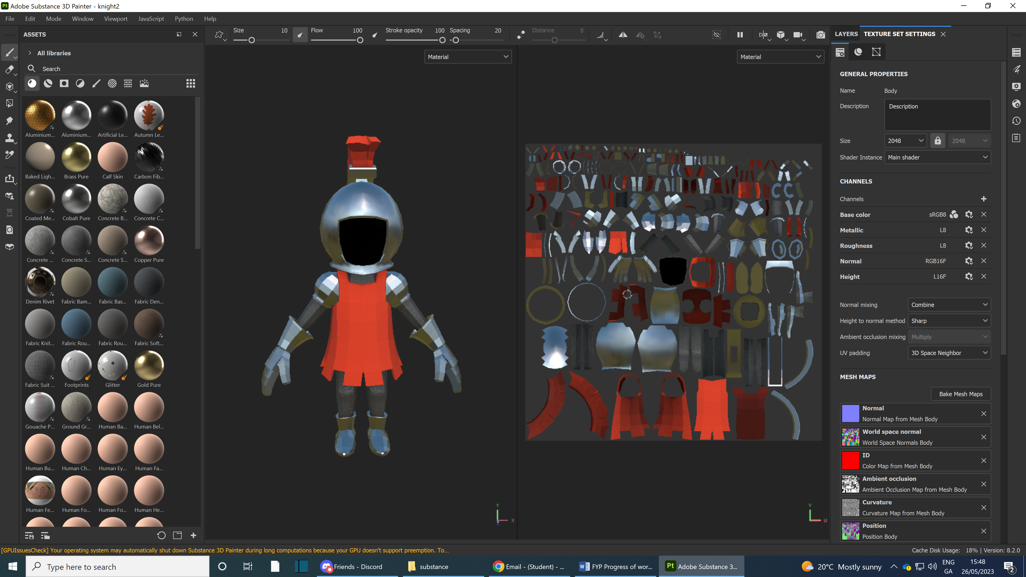

I then imported the model into blender and applied the texture. I first did the textureing by applying it to the models using the shading nodes of blender I then began rigging my model. Due to his unique shape I had to make may armature/rig from scratch.

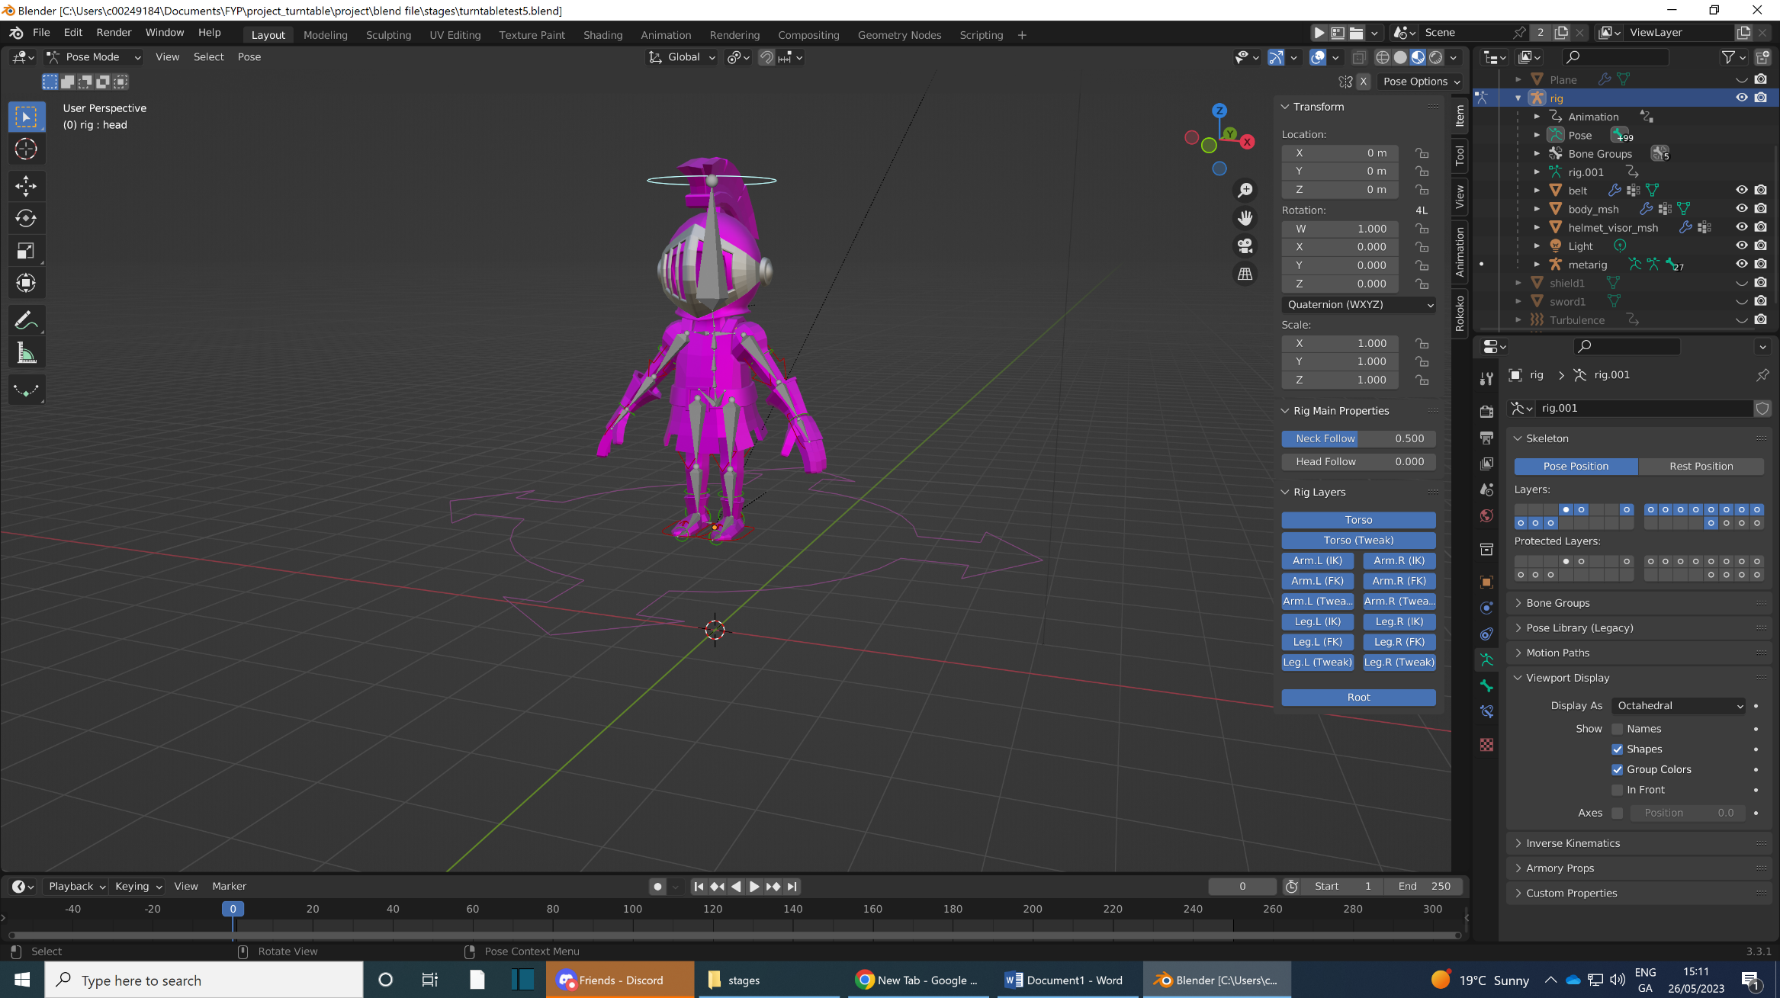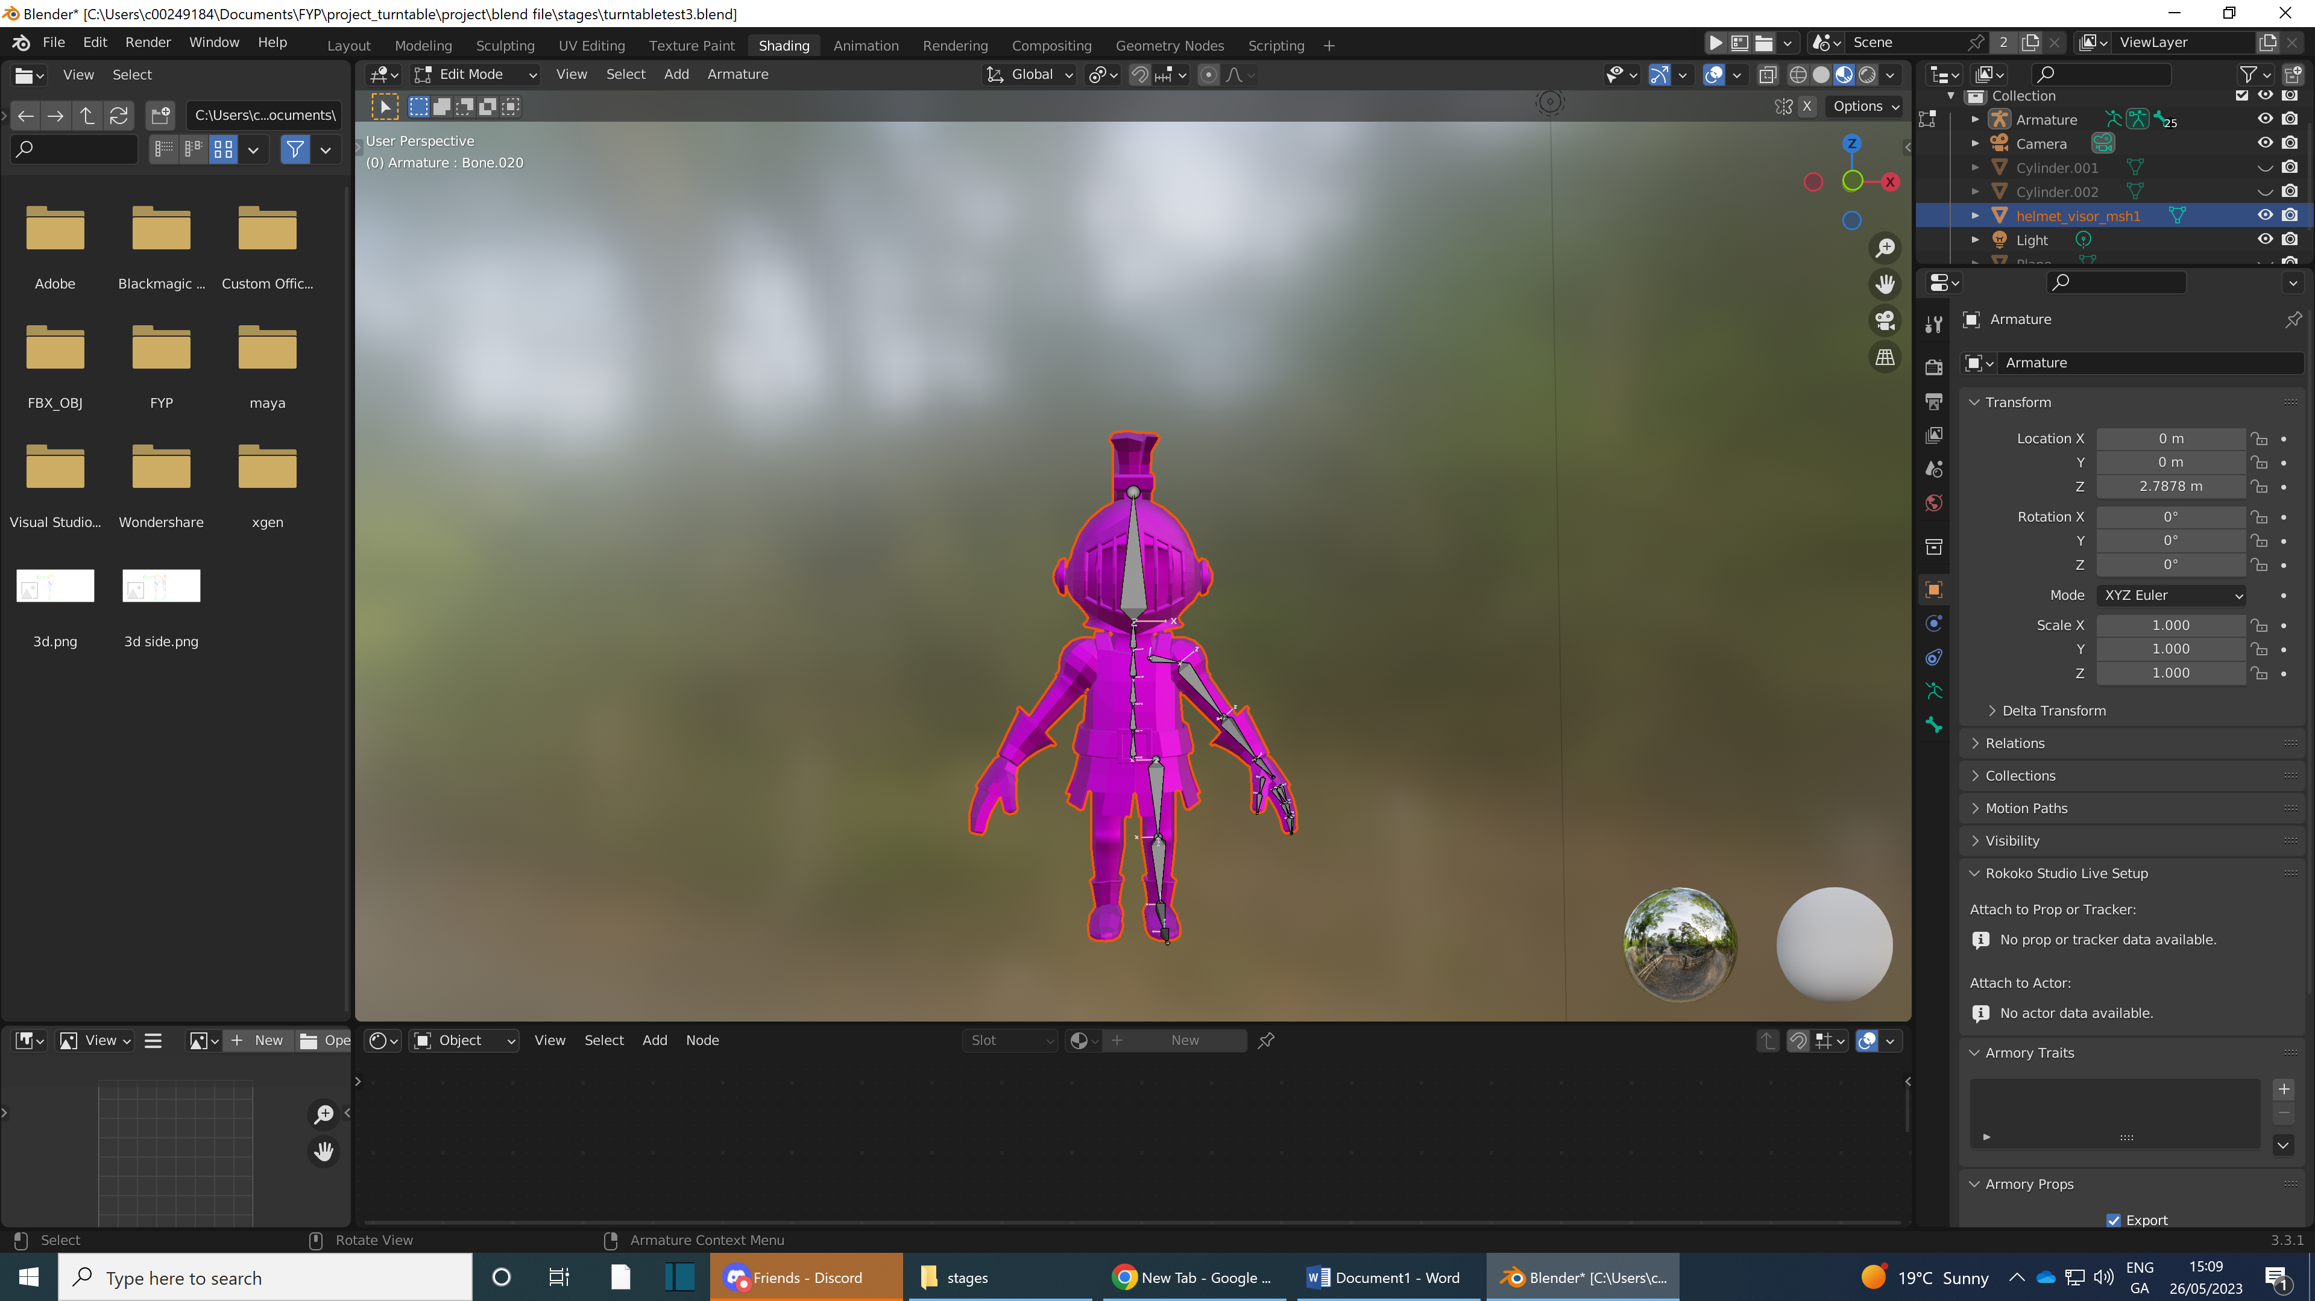

I had intended to link miximo movements to my model to animated due to it would take to long animate all different one unfortunatly they didn’t apply right to my rig due to its unique bones due to my models cartoon shape causeing a rediculous ammount of warping.

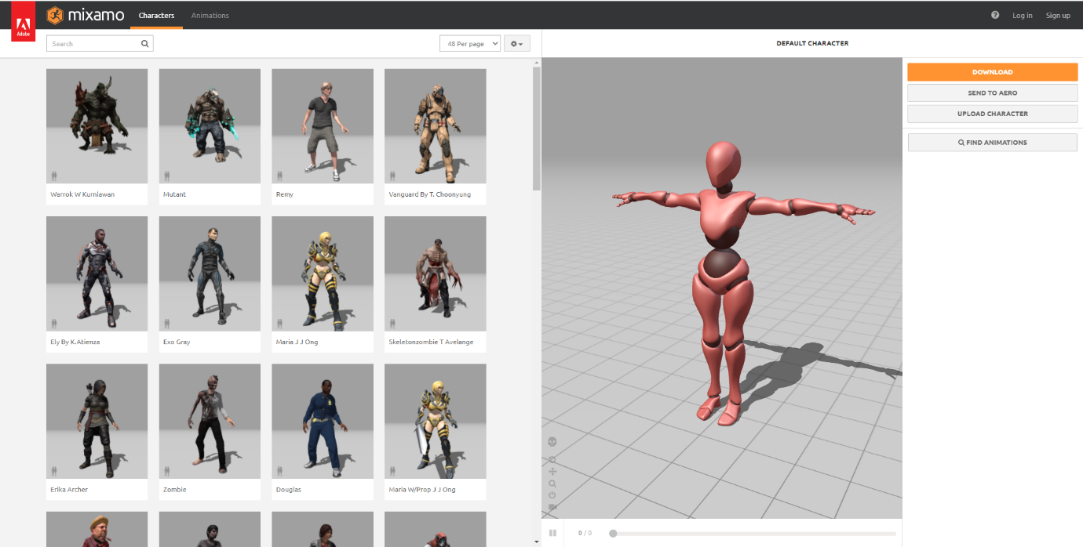

I then got a grass effect on blender as I said I’d make a effect in my project. I got it working but unfortunatly armory 3D the game engine plugin im using for my turntable builds need extra code scripting to att in the grass and I do not have the time doo takle that so I rill do some image renders and an animation.

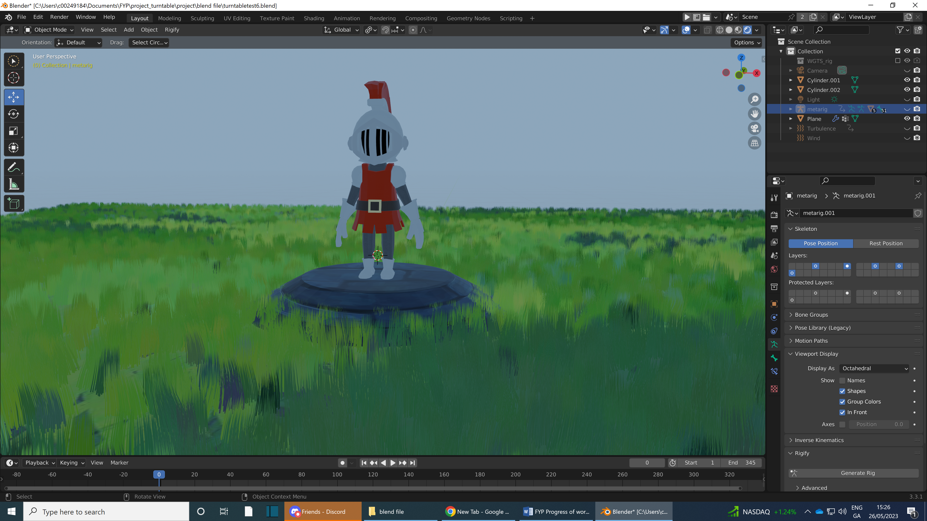

When I use Armory3D playtests and builds it will create a build folder that places all related information to your build, and when you publish a build it will put a krom_window folder which has your playable build in it. I export it as Krom windows due to using windows.



In the last few build I’m able to get the rotate and zoom but the animations for the armoury build breaks as the rig falls apart it seems when I looked up the problem armoury needs extra code to use the armature/rig properly causing my output of the character to look like a deconstructed Lego man due to this I have to cut corners due to the time left I instead created a animation and rendered it. I then video edited the rendered animation adding sound effects to the animation due to being out of time to get or learn the required code to get the animation to work.

